# A Good Father = A Good Friend

Happy Father's Day to all the Dads: the old ones, the new ones and the soon-to-be ones!

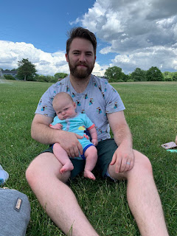

What a wonderful gift our loving Father in Heaven gave to us: fathers. And whenever we need someone who truly understands us and can help in ways that we cannot, He is there for us as well.

We are preparing to head off to church in a little bit, and then we're having a huge family BBQ this afternoon with lots of Harmons that are in the West Virginia area. It will be so fun to see everyone and to hang out together.

I need to get caught up from the last week's travels and adventures, so here we go!

Monday:

Scott and I spent the day together going on tours and self-guided tours of Nauvoo and Carthage, Illinois.

We started off the day with a hearty breakfast at the Willard Richards Inn. The host, Carmen, signed up to run the Inn for 11 weeks with her 2 children (12 and 7 yrs old), while her husband continues working for the summer. They are from Lehi, Utah, but felt this would be an amazing experience. Her 12 year old son burst in one day (not while we were there), while Carmen was serving dinner to a room full of guests, and all out of breath he declared, "Look what I found Mom! A 20 inch snapping turtle!" (which he then proudly held up and displayed for all to see) He had been down to the river, searching for one, and was so excited to have found one! He knew just how to hold it so it didn't snap off his extremities, too. A man in the dining room offered to help by saying, "I've got all boys. I know how to make all this go away!" And he did. :)

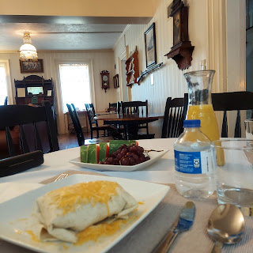

In the dining area/living room, there are plenty of historical artifacts to peruse, including these fascinating death masks of the Prophet Joseph Smith and his brother, Hyrum Smith. (see descriptions of who-what-where-why-when below)

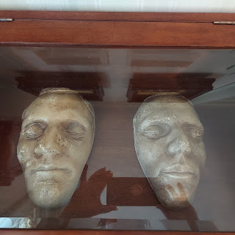

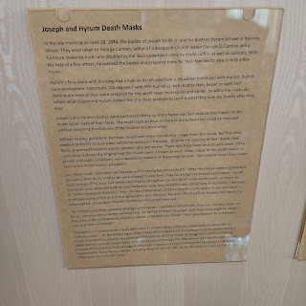

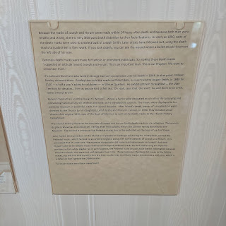

Our first tour of the day was to learn more about how they built the temple in Nauvoo back in the 1840's. We toured 3 homes and learned more about some of the background people who contributed.

The first home belonged to William and Caroline Weeks. Something of interest with his home is that he was an architect, and knew how to build more elaborate finishes, such as his arched doorway. (Sorry I didn't get a better photo of it)

The arched doorway was a statement to all the passersby that he had a talent for such things. People would know who to turn to if they wanted something special built.

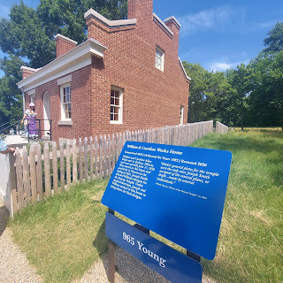

When the Prophet Joseph needed an architect to help design the temple, he was looking for someone specifically who could come up with a draft of what the temple would look like - and have it come as close to what he saw in a vision of what it was

supposed

to look like. William Weeks came up with the following drawing of what he thought the temple could look like.

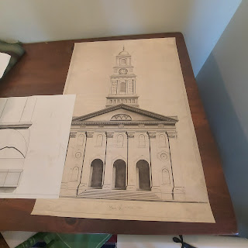

And this is what it DID end up looking like - the same as what Joseph Smith saw in his vision from God. You can see several similarities!!

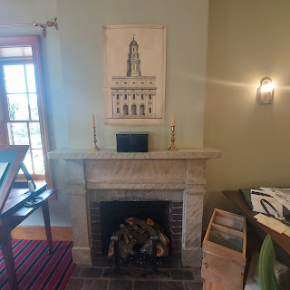

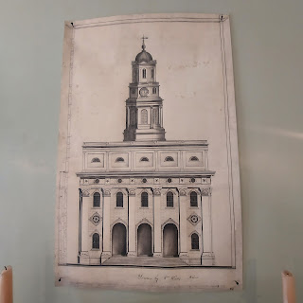

I also got to see what a nursing dress looked like back in the 1840's. I wondered how the women so long ago were able to feed their babies, and now I know! :)

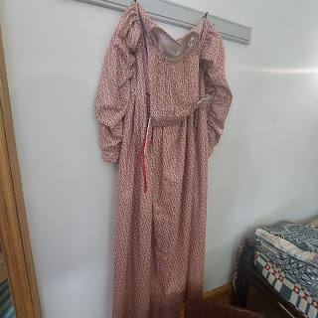

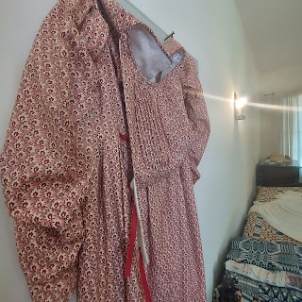

After the tour was finished, we went for a walk up the hill to see the temple.

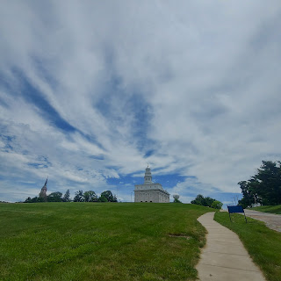

These statues across from the temple are of Joseph Smith and his brother, Hyrum. It is meant to depict their last ride together, as brothers and friends, as they rode to Carthage to be incarcerated for crimes they did not commit, and ultimately pay for their beliefs with their own blood.

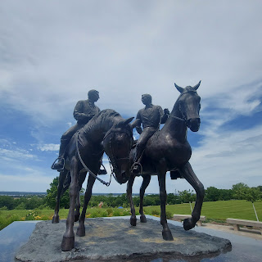

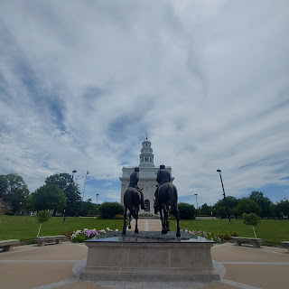

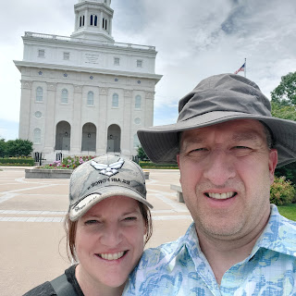

A beautiful view from the temple steps, looking down toward the Mississippi River below.

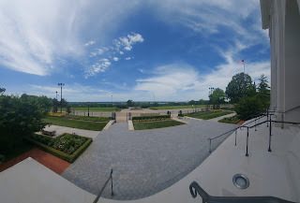

Side view of the temple.

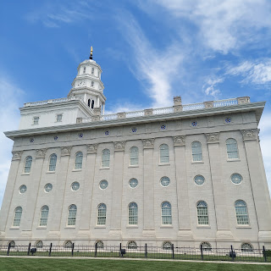

We walked over to some nearby shops, where I bought a few souvenirs. :) My happy place.

Our next tour was taking a carriage ride out in the countryside of Nauvoo. While we waited for our turn, I took a short video of the group coming back in because the horses are just so magnificent. :)

Click here to watch: (14 seconds)

https://photos.app.goo.gl/Aych5CRrixrQacPe9

This is what our horses looked like - there are two teams hitched up and they just alternate as far as taking the next tour group out. The tour itself was quite short - I was hoping it would be longer just because I love being around horses. But it was only about 25 minutes long.

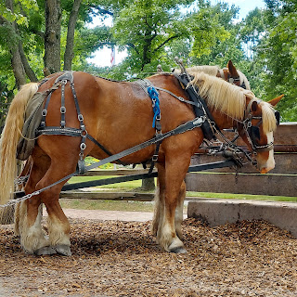

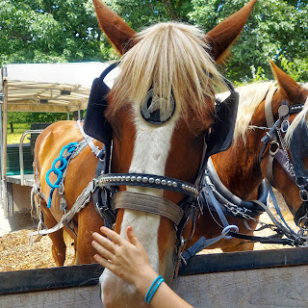

After our carriage tour, we walked over to the FamilySearch Center across the street from the temple. Someone had suggested to us that we check with them to have them look up where Scott's ancestors used to own property in Nauvoo.

While they looked up a few names for us, we waited and browsed the artwork in the foyer.

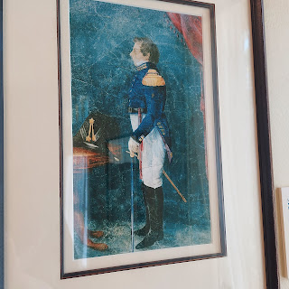

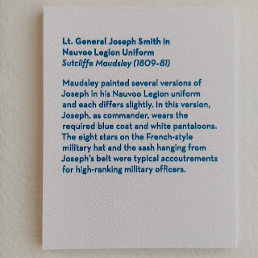

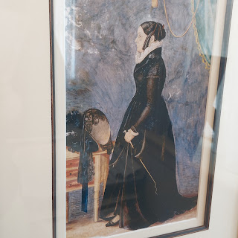

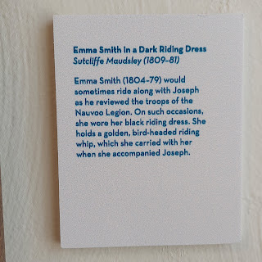

They had success in finding what we came there for: we found property locations for Appleton Milo Harmon, as well as Joseph Knight Sr. and his daughter, Polly Knight Stringham (Scott's 3rd great grandmother). More on that in a minute.

After a lovely "quiet hour" back at our lodging, we set out again for our last tour of the day: Carthage Jail in Carthage, Illinois. I had been there once before with my mom, years ago. But this experience would prove to be significantly moving for the second time.

As you walk up to the visitor's center, you see Joseph and his beloved brother, Hyrum, once again.

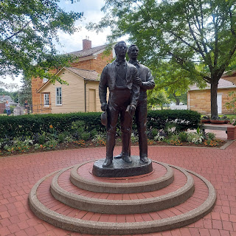

The sister missionaries did such a fantastic job in their presentation during the tour. They not only shared the facts of what happened that tragic day on June 27, 1844, but they encouraged us numerous times to look for the positive things within the story. The kindness of the jailer, the comforts that they had, etc. As we entered the room where the tragedy took place, it was very quiet and somber.

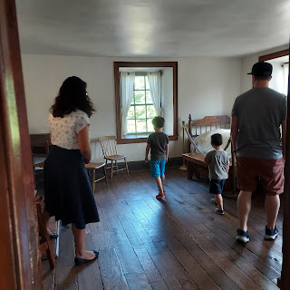

The sweet missionaries sang two verses of "A Poor Wayfaring Man of Grief" a cappella. I was bawling. It was so moving and beautiful and really brought the spirit into the room.

Then they shared how the mob of over 100 men, with faces painted black to hide their identities, stormed the jail, came up the stairs, with shots firing everywhere.

The ball that killed Hyrum went right through the door and struck him in the face, killing him almost instantly. The scar is still there today.

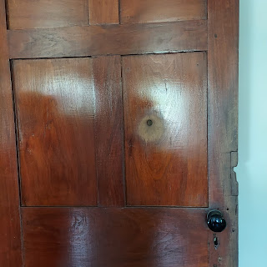

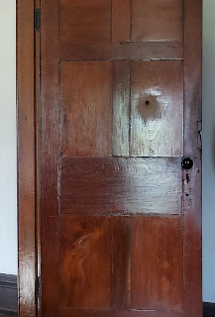

We had an opportunity to stand at the window where Joseph was hit multiple times from within the room and from the ground below, where he fell out to his death.

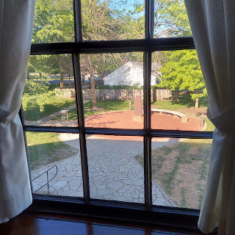

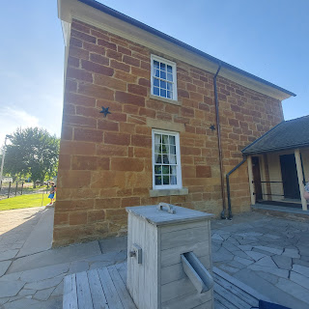

After the presentation was over and we exited outside, the missionaries asked us what our thoughts were about what we heard. I couldn't even talk. AT ALL. I was bawling so hard. Honestly, I don't think I cried the first time with my mom, but I remember feeling very somber and sober, even a little depressed. But this time, I felt the spirit so strong, both because of my love for the Prophet Joseph and his brother, for their unfailing and unyielding devotion to God and their families, but because I knew that God allowed this to happen. The triumph within the tragedy is that He took them home to rest with Him above. They had done all they needed to do in this life, and this was how God allowed it to end. He could have saved them and preserved them for more years of service on the earth, but He loved them enough to relieve them of their earthly duties and bring them them home to Him. Their work was done.

We walked, verrrrry slowly, to dinner a couple blocks away.

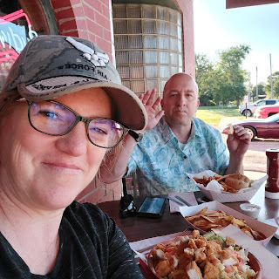

On our way back to Nauvoo, we pulled over so I could get a picture standing in a cornfield. Because it's corn country out here!

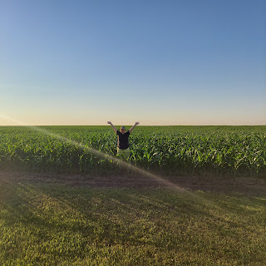

We had a little bit of daylight left, so we hurried on a walk around the neighborhood to find those properties that used to belong to his ancestors.

This is where Appleton Milo Harmon used to live.

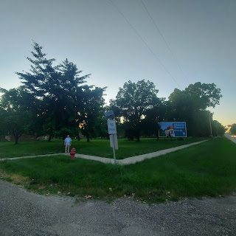

He is standing right in the middle of Appleton's property here.

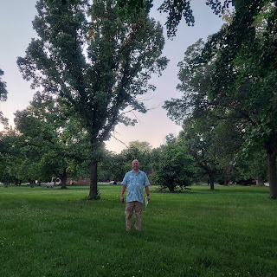

And this is one of many properties that the Knights owned in town. They owned this entire block, actually.

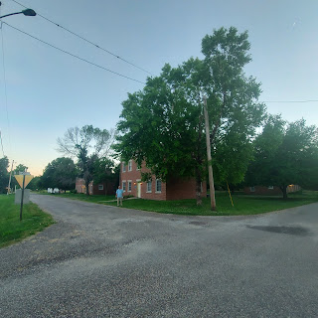

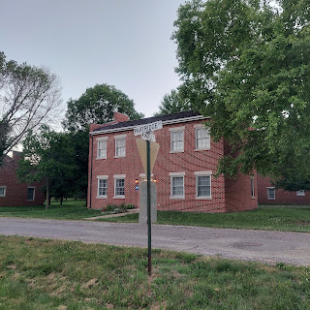

We marked on the map where the properties were.

S = Stringham (Polly Knight married William Stringham) This was down in the swampy land below the temple, where the poorer families lived because they couldn't afford to live in any better area at that time. The Stringhams eventually married into the Harmon line.

K = Knights

H = Harmon

And the little "box" I drew next to the orange label "Homes of the Apostles" is where the Willard Richards Inn is located, our lodging while in Nauvoo.

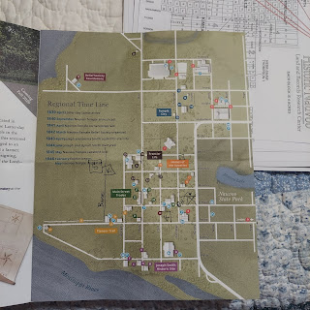

We squeaked out just enough minutes to speed-walk over to see the Joseph and Emma Smith home, known as the Mansion House.

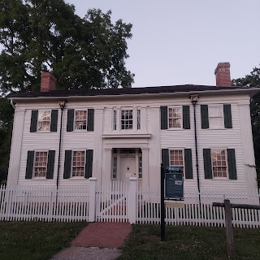

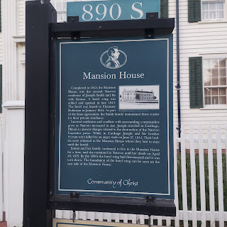

Diagonally across the street was where Joseph's parents lived, Lucy Mack Smith and Joseph Smith, Sr.

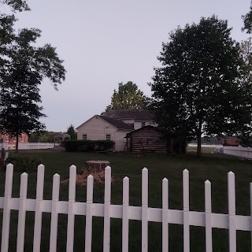

As dusk settled in, we quickly made it to the Smith Family Cemetery located on Joseph & Lucy's property.

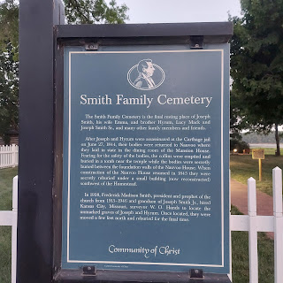

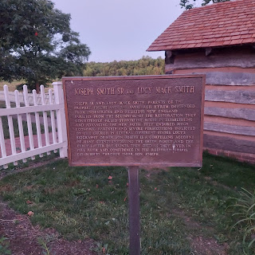

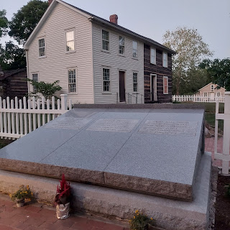

I didn't have time to really ponder and think about those whose graves I stood over, because the bugs were out in force AND there was a very interesting couple that we struck up a conversation with. Apparently there is a movie due to be released in November having to do with a surprise discovery in Nauvoo, and the man we spoke with was part of the team.

Next door to the Zion's Mercantile Store in Nauvoo, almost across the street from the temple, we noticed there is a construction project going on. I thought maybe they were digging down to construct a new business or something. Zion's is where we bought my souvenirs earlier in the day. But no, in the process of building something, they discovered a tunnel system underneath. They have evidence, as well as some circumstantial evidence, that this is where Joseph and Hyrum were originally buried, to protect their bodies from desecration and looting. He showed us pictures on his phone of the discoveries they made underground!

Anyway, it is best to just read this article to get the most accurate information on what they found.

https://www.deseret.com/faith/2021/4/20/22392762/why-a-utah-man-wonders-if-underground-vault-near-nauvoo-temple-be-tomb-of-joseph-smith-lds-history

So anyway, as we were talking to this man from St. George, and his wife, for just a FEW minutes, the bugs went to town on my legs. I was wearing shorts, and yes, I had liberally applied bug spray before we left our hotel room. But that meant nothing to the gnats. It kept the mosquitoes away, but the gnats had a feast on my legs.

I look forward to seeing this upcoming movie - due out in the fall of 2021. The film crew had just arrived in Nauvoo on Monday, and planned to do some filming later in the week. Some of the crew and producers would even be staying at the Willard Richards Inn, where we would be leaving the next day. Sadly, we would not get to meet anyone else. But we were intrigued by and enjoyed meeting this man from St. George.

Tuesday:

Before leaving Nauvoo, we took a few minutes to walk down Parley Street toward the mighty Mississippi, and ponder the evacuation of the pioneer saints when they were forced to leave town in the middle of winter because of persecution.

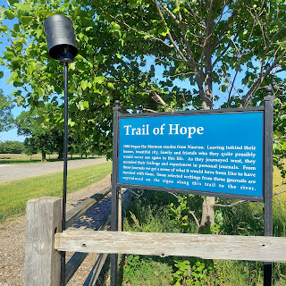

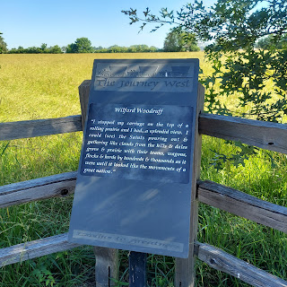

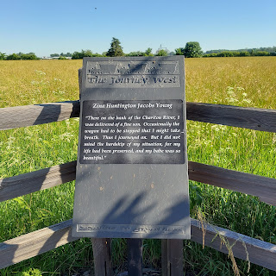

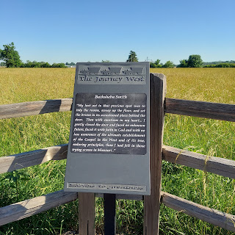

A distant view of the temple from the trail leading to the river.

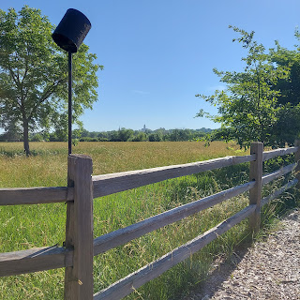

Newel Knight was a brother to Polly Knight Stringham.

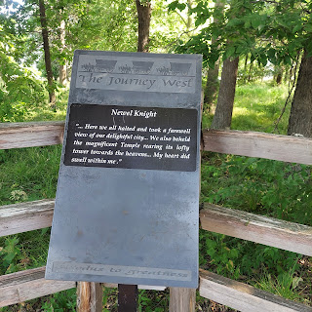

And this was part of the "swampy" land that was reserved for those who couldn't afford anything more when they arrived in Nauvoo. This included the Stringhams. It was very close to the river.

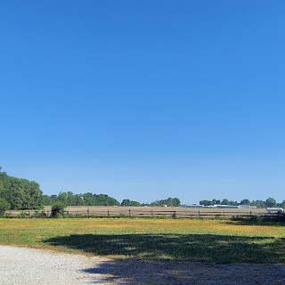

We literally RAN down to the water's edge to catch this huge barge heading downstream.

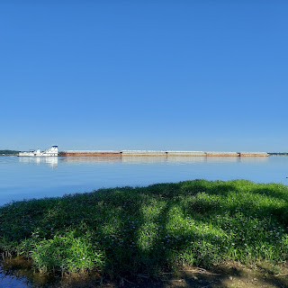

Short video of the barge: (24 seconds)

https://photos.app.goo.gl/4MGsdLEkh3tHxSw9A

And a short video of a giant turtle digging down into the Trail of Hope. (24 seconds)

https://photos.app.goo.gl/mXxHfNWPN6BarXUx8

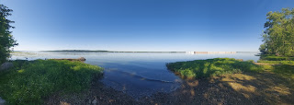

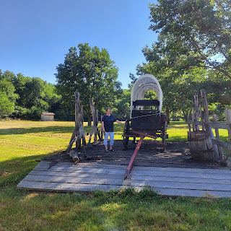

Goodbye Beautiful Nauvoo!

Time to drive all the way across Illinois and Indiana into Ohio. All in one day.

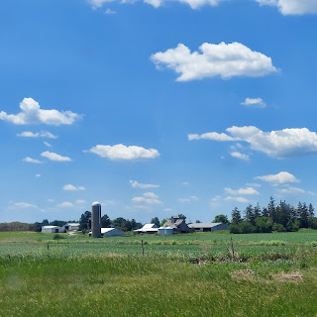

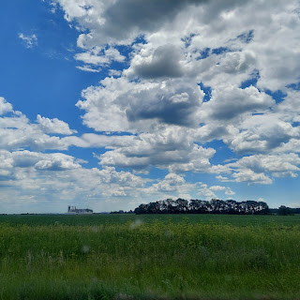

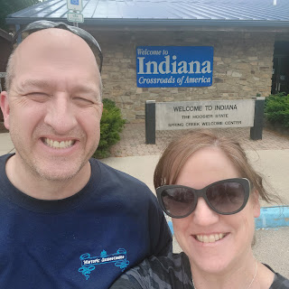

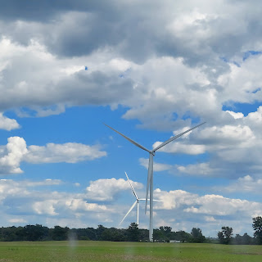

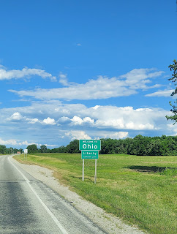

After we checked into our hotel in Troy, Ohio (where my great grandparents Leon Jones and Christina Miller Jones used to live), we drove 7 more miles north to Piqua for dinner. Piqua, Ohio is where Christina used to live and work in the Superior Underwear Factory. They made long johns, men's underwear, women's underwear, etc. It was known as the Underwear Capital of the World in the early 1900's.

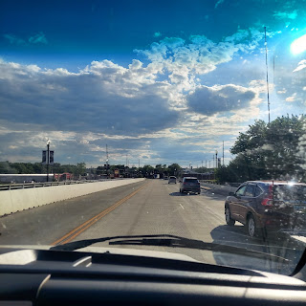

There was a flood in 1913 of epic proportions! This is the water line on a plaque in downtown Piqua. (pronounced Pick-wuh)

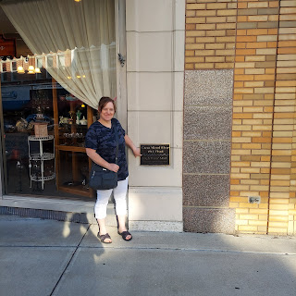

While we waited for dinner at a cute little shop called Susie's Big Dipper, (sandwiches, soups, and ICE CREAM!!) I took some pictures and messaged back and forth with my mom regarding our family history from Piqua.

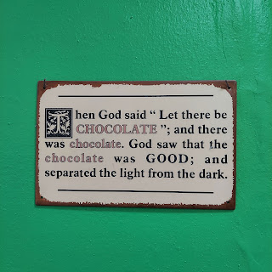



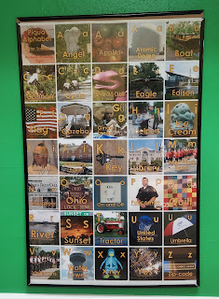



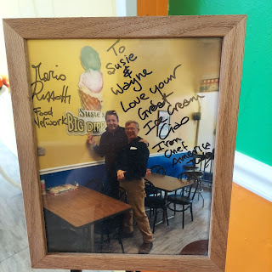

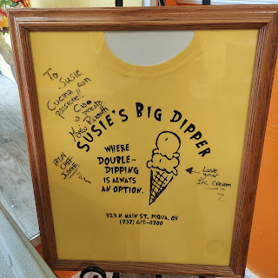

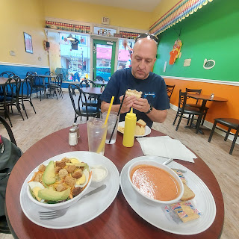

This is now the local library, but it used to be a hotel. From the balcony above the entrance, there have been some famous speeches given by U.S. presidents, among others.

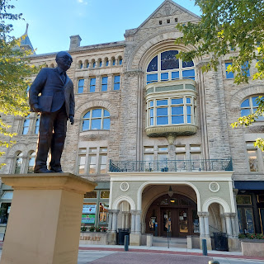

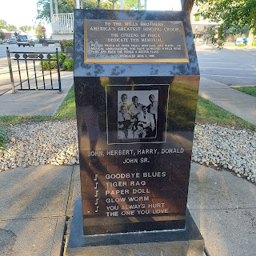

Another view of the massive and beautiful old hotel, now serving as a library.

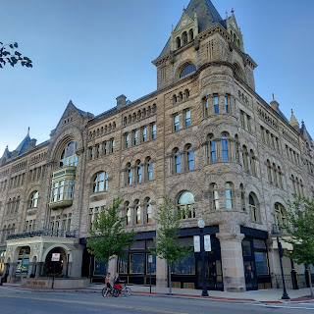

The Erie Canal runs right through town, so we walked along the path after dinner for a bit. It felt really nice to be out of the Uhaul truck.

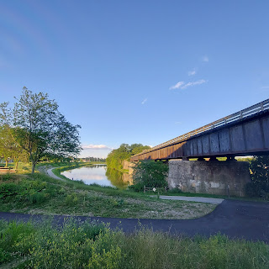

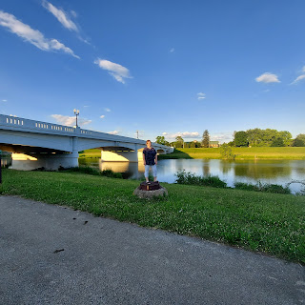

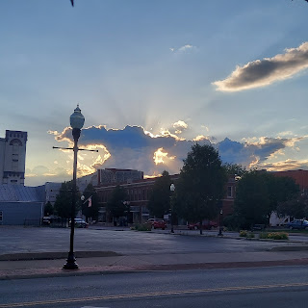

Christina used to live in this little house in Piqua. On the back of this photo, she recorded, "Our house in Piqua O, where I nearly lost my life in a flood." As the story goes, someone had to come and rescue her and her roommates from the building and were then taken elsewhere in a BOAT!

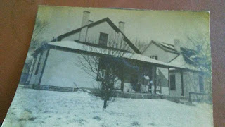

This postcard showing the extent of the damage, would have been similar to Christina's experience of being rescued. According to the locals, it was just a lot of heavy rain in a small amount of time. After the flood, the town built a levee to prevent future catastrophes.

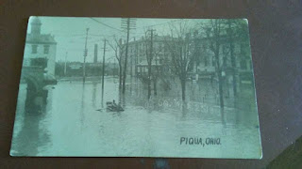

While my mom was busy digging through Grandma Doris' old boxes stored in her garage, Scott and I finished our evening walk and were eager to get back to our hotel for the night. Later, we were able to piece together just how close we were to where Christina was in 1913.

803 N. Downing Street was the factory where she worked. Superior Underwear.

426 E. Greene St. was where she lived and had to be rescued by boat.

And we ate at Susie's Big Dipper (letter B on the map)

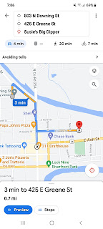

I found an online photo of what it looked like when the ladies used to work at the factory there.

Here is the explanation: (very interesting!!)

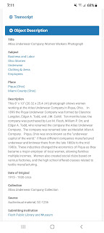

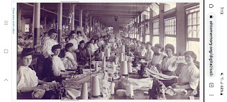

And an ad for Superior Underwear!!



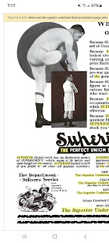

Wednesday:

We hit the road for our LAST LONG DAY of driving!!!

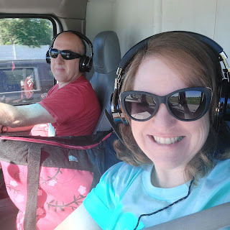

Coming into Wheeling, WV for lunch.

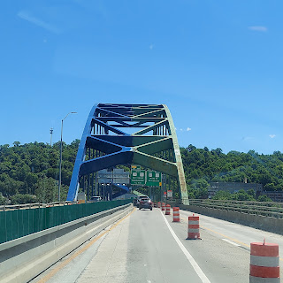

Tito's Sloppy Dogs. SO GOOD!! Scott ordered the Bow Wow Dog with chipotle sauce, while I ordered the WV Dog, with their special chili sauce and cole slaw. It was amazing.

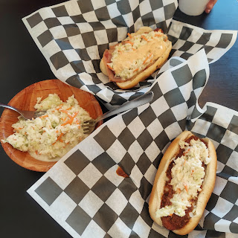

Scott put a pin in for Idaho Falls on the map while we waited for our food.

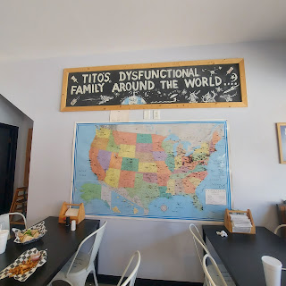

We drove across a little corner of SW Pennsylvania for a minute, before heading back into West Virginia again.

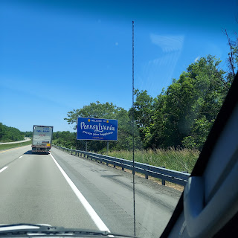

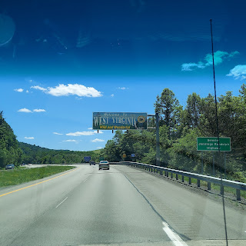

I love the Hometown USA spirit in the small towns out here. They post flags of service men and women along their main streets.

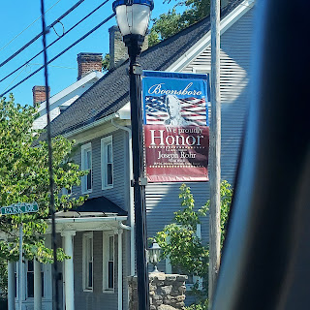

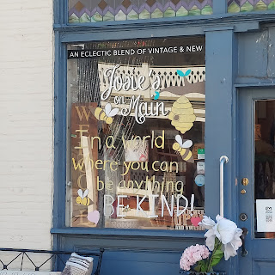

Finally, we knew we were close to Harpers Ferry because we crossed the Potomac River and shortly thereafter, the Shenandoah River.

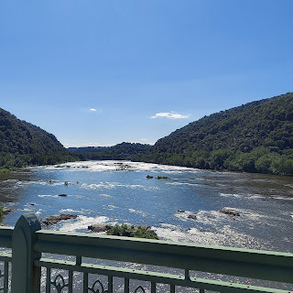

After a lovely welcome, getting settled in, and some dinner, we went outside to relax for a bit and go for a walk around the neighborhood.

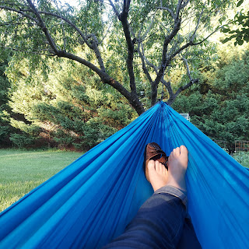

If any of you have wondered what a cicada looks like, well, I got to see one up close and personal. As I relaxed in the hammock, I saw this giant thing in my peripheral vision on the pear tree to my left.

Click to watch: (22 seconds)

https://photos.app.goo.gl/UiV8eQFLyMBjtEDP7

Their mating season is winding down now, maybe a week or so left. They are SO LOUD. And they love humming engines and motorized machinery. For example, Pam was out vacuuming her car on Friday, and she forgot about how the cicadas love that kind of stuff. They started swarming her and landing on her and in the car!! That would be so freaky because they are NOT small. They won't hurt you, but they like to grab on to your clothes to anchor themselves in order to perch. Ewww.

Jacob and Hannah made it late that evening, along with Jack and Hannah's mom, Michelle. We all stayed the night at Gordon and Pam's house together. So much fun to have a sleepover!!

Thursday:

After a good night of rest, we got up and prepared to head in to Washington DC to begin moving the kids into their new apartment.

Scott, Gordon, and Jacob headed out first, while Hannah, Jack, Michelle, and I took our time getting ready to meet them in town.

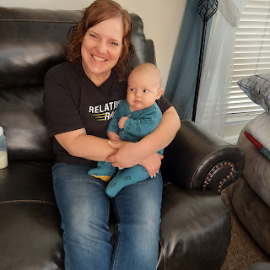

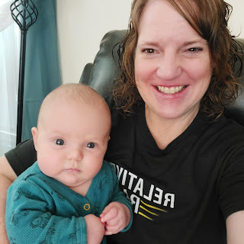

Jack's second cousin, Azure, met him for the first time. She kept pushing the snap on his pajama tummy out of curiosity. :)

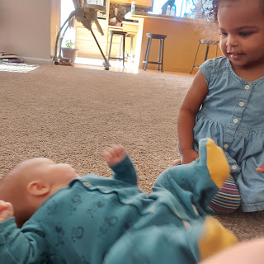

And she was very soft with him. At least for the first few minutes, ha ha.

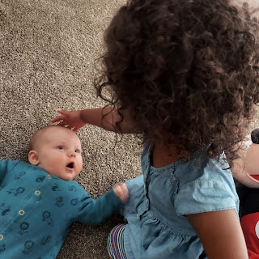

Time to get to work in DC.

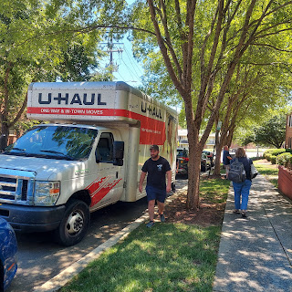

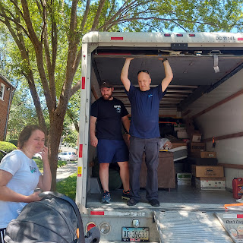

Jack was extremely helpful. Mostly because he is the best moral support. :)

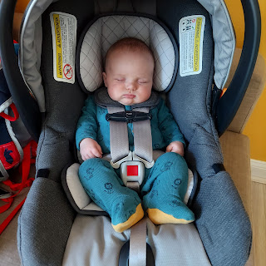

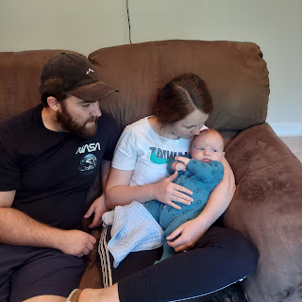

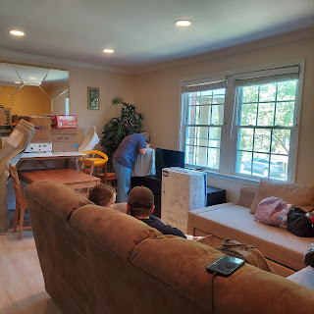

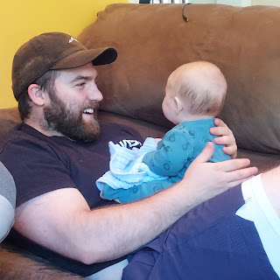

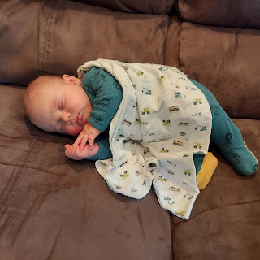

The landlord mistakenly thought that they wanted the apartment furnished. It was very crowded at first, getting all of Jacob and Hannah's stuff into an already furnished apartment. But after we emptied out the Uhaul,

we loaded it all

back up

with the unwanted furnishings. What a chore!

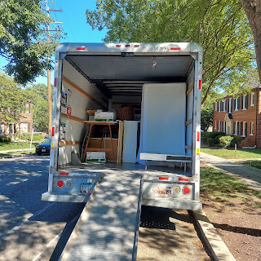

Gordon was a huge help. It was nice to have 3 strong capable men, while the 3 women carried the smaller boxes and items up and down the 2 flights of stairs.

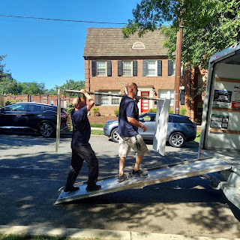

We met the landlord's brother at a Uhaul storage facility to store all the extra beds, dressers, desks, and other furnishings. And then we dropped off the Uhaul truck once and for all at the same place. What a huge relief to have accomplished a drive across the country and to get the kids all moved in! Yay!! We did it!!

Gordon then drove us all the way across town to the Dulles International Airport to pick up our rental car. On the way, we passed by the Washington DC Temple. It is SO BEAUTIFUL!! After 3 1/2 years of massive renovations, it is due to reopen later this year.

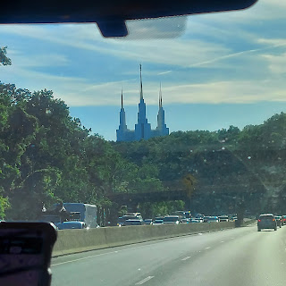

Finally, we parked in the church parking lot behind Gordon and Pam's house, and followed the trail through the trees to their backyard. It's much quieter and nicer to be in a rental car instead of the LOUD moving truck. Much smoother to drive too. :)

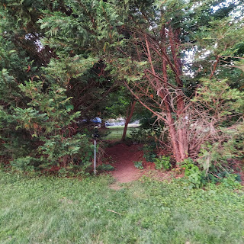

Friday:

We went over to the Walmart in Harpers Ferry to visit Scott's sister, Sharon, who works there in the fabric department. Scott, whose shirt looks like it says CRAMPS, actually says Gramps. He always loves to be silly though, and act like he's really having cramps. :)

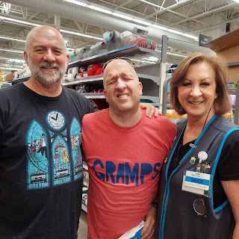

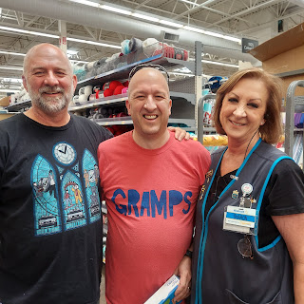

I found some cute fabric for Sharon to cut for me. I'm always thinking about the next quilt I can make!

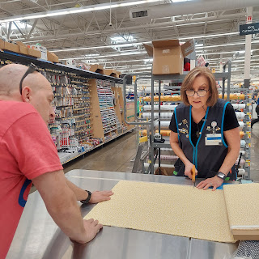

Meanwhile, Jacob and Hannah went on a nice long tour of some of the DC monuments with Michelle for the day. They took the train in from their apartment instead of driving in and trying to find parking.

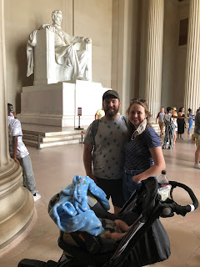

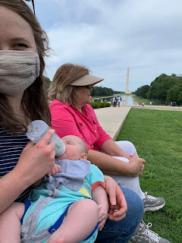

And back in Harpers Ferry, we went on a double date with Gordon and Pam on a motorcycle ride through the country roads to Shepherdstown, WV.

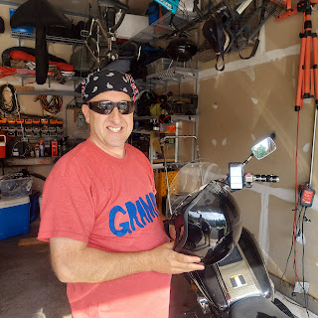

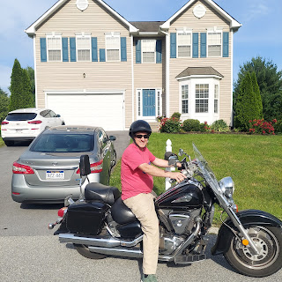

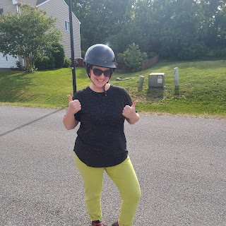

Scott and Me

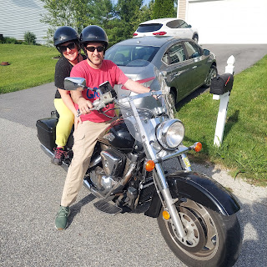

Gordon and Pam

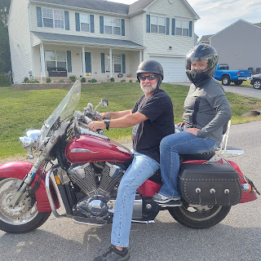

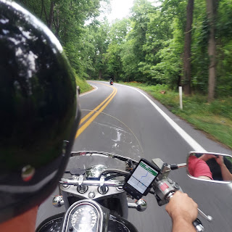

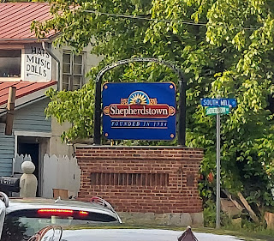

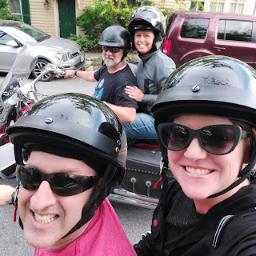

After dinner, we drove down to the Potomac River outside of Shepherdstown. Gordon and Pam's friends had some kayaks that we could hop into and enjoy paddling around for a bit.

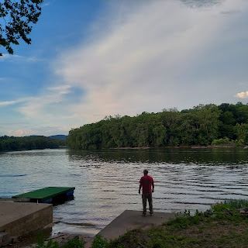

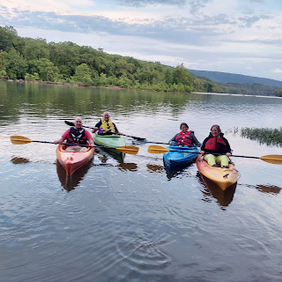

As we drove the rest of the way home, the sun was setting, making for a beautiful skyline.

Click here to see the sunset from the back of a motorcycle: (20 seconds)

https://photos.app.goo.gl/ERCY3BsGQ8yn9pM56

For more motorcycle adventures, you can just see the album that I made - most are short video clips.

https://photos.app.goo.gl/XBZuMCJMxu3uRYs17

Saturday:

In the morning, we took another short drive out to Charlestown to visit Scott's other sister, Bev and her husband, Ken.

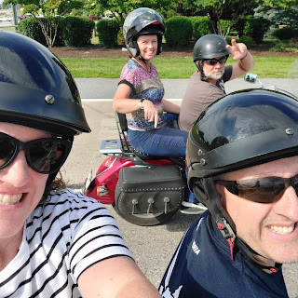

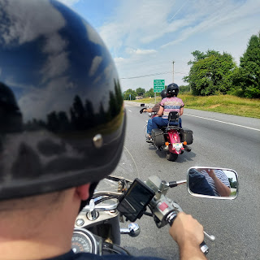

Historic Charlestown, WV.

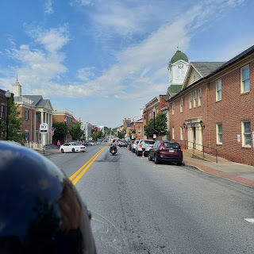

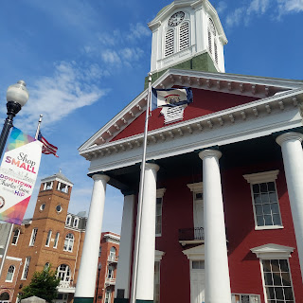

Short video of us driving down the gravel lane leading up to Bev & Ken's house: (44 seconds)

You'll see Ken mowing his lawn as we pull up.

https://photos.app.goo.gl/rWVLKPqJgC3Dcaaa6

They gave us a tour of their house and beautiful old barn. We even climbed up the ladders to go up into the rafters. The barn used to be a place where the apples were processed and packaged up a long time ago, and there are thousands of apple boxes still up there.

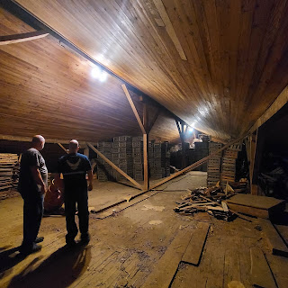

And even some old barrels.

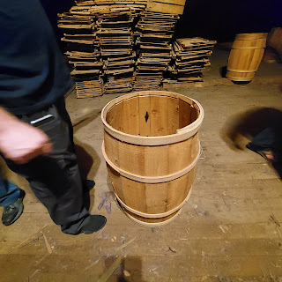

Bev and Ken

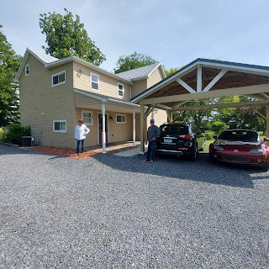

Soon, though, we headed back on the motorcycles to Harpers Ferry, to swap out to our rental car instead. We drove into DC to visit our kids again and hang out with them for the rest of the day.

Traffic was a beast, even on a Saturday. We had time to take photos of the Washington Monument across the river while we crawled along.

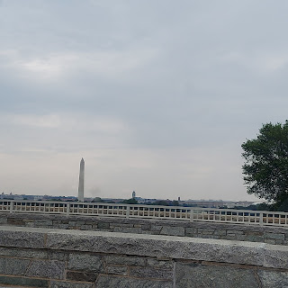

Papi got to feed Jack.

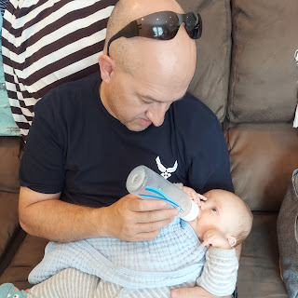

While I got to play!

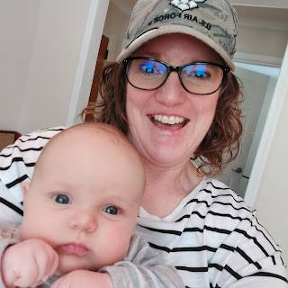

Until he fell asleep again, ha ha

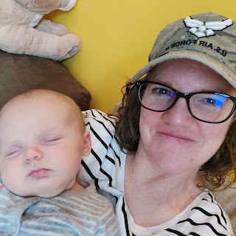

Scott helped Jacob put a desk together for his new office, while Hannah and her mom were touring Mt. Vernon, George Washington's original estate overlooking the Potomac River.

Eventually we met them at Reagan International Airport to say goodbye to Michelle. And then we drove over to Arlington National Cemetery, since we were really close at that point.

We got there just in time to see the final changing of the guard of the day at the Tomb of the Unknown Soldier. This is a very special place, to symbolize the lives lost of military personnel whose bodies have not been identified. For 100 years, this has been a place to commemorate their service, and it is treated like a holy shrine. There is no talking, and the guard silently marches back and forth while on watch.

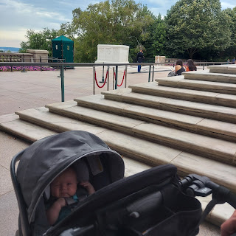

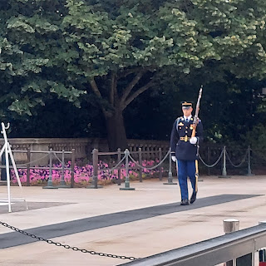

Periodically - maybe every 30 minutes?? - they swap out. It is a very formal procedure, again, done in in complete silence.

You can see a couple of video clips here:

Getting ready to change out: (2 1/2 minutes)

https://photos.app.goo.gl/iv7uGJHWGpYu1MZv7

And once they're changed out: (50 seconds)

https://photos.app.goo.gl/pC8TJyDTnanEqQ1R7

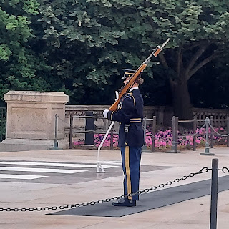

It was beautiful to be a part of the ceremony. Even though sweat was literally dripping down my back the entire time.

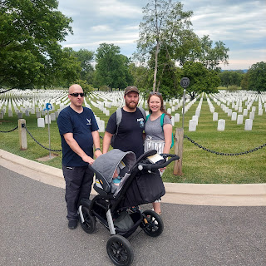

We were a little closer to the Washington Monument while driving back to their apartment.

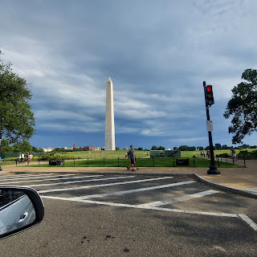

After a very long couple of days for Jacob and Hannah, moving in and all the sightseeing, they were tired and hungry. After a couple of foiled attempts to get dinner, we finally just settled for picking up a few groceries at Safeway and calling it a night. (First we tried to find parking near an awesome sounding restaurant - Cava - but the Nationals game was just getting out and parking was like $30 each. Then we tried using Door Dash to order food and have it delivered, but close to their apartment, the driver got a flat tire and wasn't able to bring us our food. He was already away from his car - getting a ride to swap out his tire, so it wasn't like we could just run over and pick up our food from him.)

They wanted to come back to Harpers Ferry to spend the night out there with us, feeling a little overwhelmed by inner-city DC. We left town pretty late and arrived in Harpers Ferry around 11:30 p.m. After some discussion this weekend, they have decided to look for another place to live. The apartment they are in right now is fine, although cramped and small (only about 700 square feet with 2 bedrooms). The kitchen is about the same size as their bathroom: small. But that's not the issue. The issue is the neighborhood in general. Their street is fine - the cars are nice, the street is clean and feels safe. But if they want to go anywhere past their street, it is a whole different story. As they walked 1 mile on Friday with Michelle's mom to use the Metro into downtown DC, they saw a lot of things that made them really uncomfortable and even anxious.

There are no parks nearby - the nearest park is a 15-20 minute drive away, and Hannah really doesn't feel comfortable taking Jack anywhere by herself when the time comes for Jacob to commute in for work. (Right now he is working remotely - using a government-issued laptop and can work from home for a while)

So after much prayer and discussion this weekend, they will probably stay put for 2 months (having given the required 2 month notice to their landlord), while they look for a better place to live for the rest of the 2 years they will be here. One of the areas they are interested in moving to is Rockville, Maryland. Everyone says it is a nice place to live, and the Red Line goes straight into Jacob's job from there. It would be a 30+ minute commute on the subway, but that's okay if it means a better quality of life and feeling happy.

I told them it's okay if the first apartment didn't quite work out. They only saw photos online and couldn't really put it all into perspective from Utah. It's okay to want something better and safer and more comfortable. So we'll see how things shape up in the coming weeks.

Sunday:

FATHER'S DAY!!!

Breakfast in bed for the love of my life.

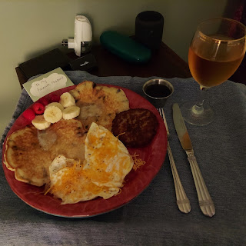

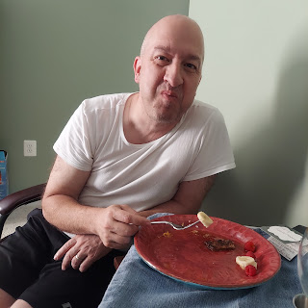

At church, all the men received these cute little tokens of love and appreciation from the ward.

(The bag of Hershey's kisses has a short verse from a children's hymn that they typically sing for all the dads on Father's Day)

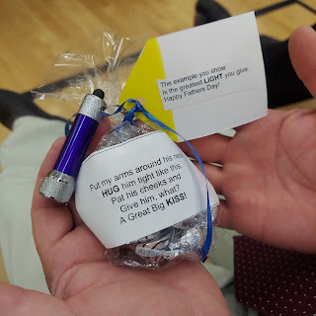

I snuck a cute photo of Scott, Assan, and Gordon during Sunday School. :)

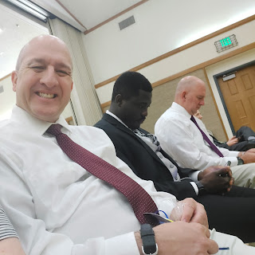

After church, we had a huge family shindig at Gordon and Pam's house.  BBQ meat, potato salad, fruit salad, chips, roasted vegetables, coconut cream pie, and black raspberry cheesecake! Yumm!

Their daughter, Marissa, and her husband, Assan, are due in 2 months with another baby girl. Azure will have to move over and make room for a little sister! :)

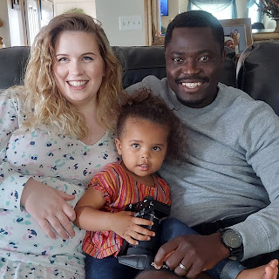

I insisted on family photos since we had so many people gathered in one place!

First up: the siblings. They're laughing because Azure was photo-bombing them and was giggling all the while. :)

Top: Scott, Azure, and Gordon

Bottom: Bev and Sharon

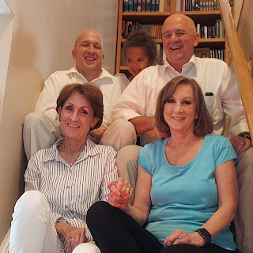

Then it was siblings with their spouses.

From the top of the stairs:

Scott and me

Gordon and Pam

Bev and Ken

Sharon and Thom

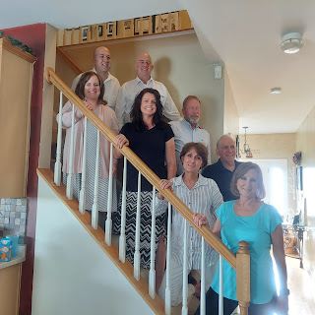

Then it was the group photo that Assan set up oh-so-beautifully with my phone on a barstool using the timer. We took ONE photo and it turned out perfectly the first time!! How about that!

From the left in front of the stairs:

Azure being held by Marissa, Hannah, Jacob holding Jack, Assan down in the front, Sydney Dever, Brendon Dever, and Mason Dever. Brendon's wife, Emily, couldn't make it because their 6 year old son, Jackson was not feeling well. But Emily Dever is Bev's daughter. Brendon is a Lt. Colonel in the US Army and has been working at the Pentagon here in DC.

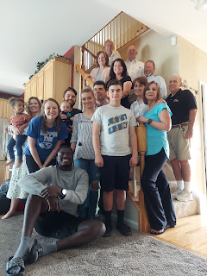

We also took some pictures of the two brothers, since they looked like twinnies.

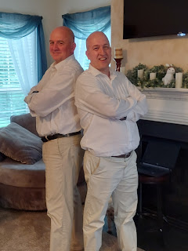

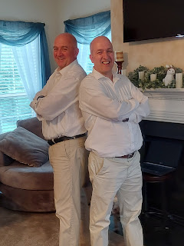

We all enjoyed passing Jack around and giving him lots of snuggles. I might have loved it the most.

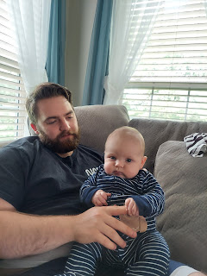

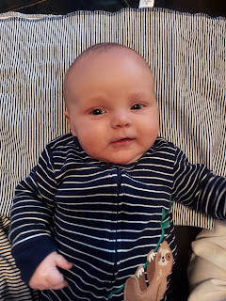

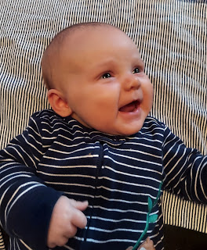

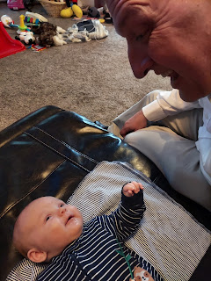

Here are a couple videos of him being so cute and chatty lately.

Video #1: at his new apartment in DC (40 seconds)

https://photos.app.goo.gl/YDkyhRbUTduNuMVe8

Video #2: Sunday night after most of the company had left (13 seconds)

https://photos.app.goo.gl/PKaH16V6wDtzNXhq9

Video #3: Still chatty and adorable (19 seconds)

https://photos.app.goo.gl/RnZcopDhRBk5TbmP9

After Jacob and Hannah took Jack back to DC for the week, Scott and I drove over to Charlestown to visit Sharon and Thom for a little bit at the end of the day.

The sun was setting perfectly for our enjoyment once again.

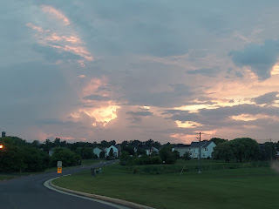

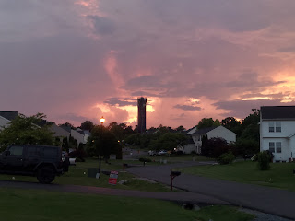

Right now, Scott is waiting for me to finish up this LONG post so we can head out on our Round 2 Adventure for the week. We are heading to Morgantown, WV, Kirtland, Ohio, Niagara Falls, Palmyra, NY, the Finger Lakes region of upstate New York, and Lancaster, PA.

Off we goooo . . .